Computer Organization and Assembly Language:

Project Report


Project Title:
Library Management System in Assembly Language

Proposed to:

Ms. Seema Hashwani

Prepared By:
24k-0711-Om-karan
23k-0926-Bahadur
FAST-NUCES

Introduction
This project is a console-based Library Management System (LMS) written in x86 Assembly Language and built using the Irvine32 library for Windows. The system demonstrates low-level programming concepts while offering a practical application in educational environments for managing book inventories, student registrations, and rental transactions.
The LMS enables two types of users:

Librarian

  - Customer (Student)

Each type has access to features relevant to their role.

Objectives
  - To implement a basic yet functional LMS at the hardware-near level.

  - To demonstrate practical use of Assembly-level constructs such as memory addressing, looping, data structures, and conditional branching.

  - To simulate real-world book handling processes such as rental, return, and
registration using a low-level programming paradigm.

Tools and Environment
  - Language: x86 Assembly (MASM Syntax)

  - IDE: Visual Studio / MASM assembler

  - Library: Irvine32 (for I/O operations and system calls)

  - Platform: Windows 32-bit

System Features
📂 Librarian Functionalities

Feature | Description
Add Book | Allows adding a new book with title, author, ISBN, and quantity.
Update Book Info | Update book title, author, or available quantity using the ISBN as key.
Display Library Info | View all stored book titles, authors, ISBNs, and available quantities.
Display Book Info | Retrieve detailed info of a specific book using its ISBN.
Register Student | Allows librarians to register a new student with name and ID.
Close Library | Exits the program gracefully with a goodbye message.

Customer Functionalities

Feature | Description
Login | Authenticate using Student ID.
Rent Book | Allows the customer to borrow a book, limited to one book at a time.
Return Book | Returns the currently rented book and updates quantity.
Logout | Logs the customer out and returns to the main menu.

Data Structures
  - Arrays (used for book titles, authors, ISBNs, rental tracking).

  - DUP Directive for static memory allocation (e.g., for 50 books and 50 students).

  - Local variables for procedure-level temporary storage (LOCAL keyword).

  - Registers: EAX, EBX, ECX, EDX, ESI, EDI used for operations and loops.

Program Flow

➤ Welcome Sequence
A graphical ASCII-based welcome screen is shown using customized delays and color changes for animation.

➤ Main Menu
User chooses between "Librarian" or "Customer". Depending on the input, the corresponding submenu is shown.

➤ Procedure Calls
Each menu option leads to a clearly defined PROC in the .code segment. For instance:
- AddBook PROC

- UpdateBookTitle PROC

- RentBook PROC

Each subroutine is modular and handles its own I/O, processing, and memory operations.

Key Highlights
  - ✨ Efficient Use of Memory Offsets: Book title/author manipulation done using calculated memory offsets (e.g., mul ebx to access specific slots).

  - 📏 Fixed Allocation Strategy: Ensures no dynamic memory leaks and provides deterministic performance.

  - 🔁 Loop-based Searching: ISBN matching and user verification are implemented using loop iterations and conditional jumps.

  - ✅ Error Handling: Informative messages like Book Not Found, Invalid Choice, and No More Copies guide user behavior.

Screenshots

📸 Recommendation:
Capture screenshots of the following outputs and add them to the final document or presentation:
- Welcome ASCII Art Display
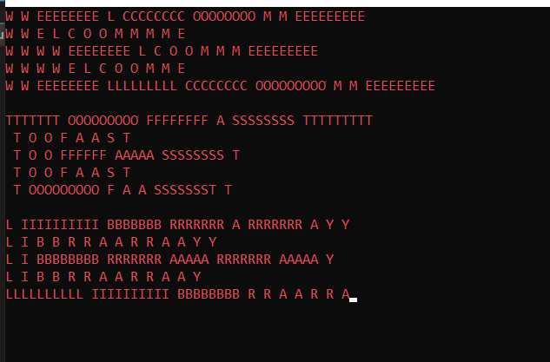

- Main Menu Prompt
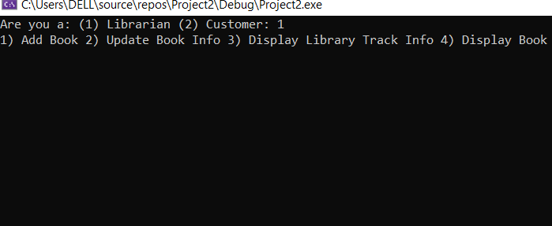

- Add Book Interaction
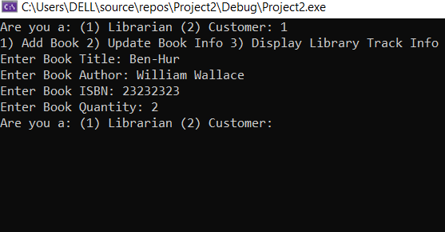

- Student Registration Output
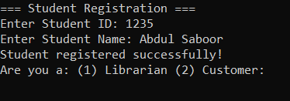

These visuals help demonstrate the program’s interface and behavior during execution.

Limitations and Challenges
  - ⚠ Limited UI: Text-based UI due to console constraints.
  - ⚠ Single-book rental per student: The current model allows only one rental per student.

  - ⚠ No file-based persistence: Data is lost once the program ends.
  - ⚠ Hardcoded array sizes: Fixed memory allocation might waste space or limit scalability.

Future Enhancements
  - 🔁 Implement file I/O using system calls or interrupts to enable data persistence.

  - 📚 Allow multi-book rentals and maintain history per student.

  - 🔒 Add a login/password system for librarian authentication.

  - 🌐 Extend to GUI using Windows API or integrate with C/C++ front-end.

  - 📈 Add reporting features: most rented books, overdue returns, etc.

Conclusion
This project successfully demonstrates the capability of low-level programming to manage real-world tasks such as a Library System. Despite being limited in UI and features compared to high-level implementations, it provides a strong educational insight into memory management, procedural decomposition, and control flow in Assembly language.
The modular design and detailed operations of this system make it an excellent candidate for teaching system-level programming, structured logic, and data handling without abstraction.

References
  - Kip Irvine, Assembly Language for x86 Processors

  - Irvine32 Library Documentation

  - Intel 80386+ Instruction Set

  - MASM Assembler Docs

  - [University-specific resources]

